Team Alpha: Rusty Degarmo, Mitchell Kwon, Aurora Lopez, Lucas Ramsey and Parrish Ward

Case Study: Outland Adventures

Revised ORD:

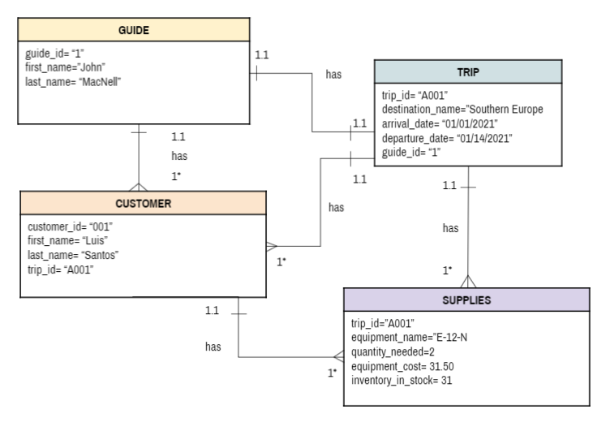

Guide table output:

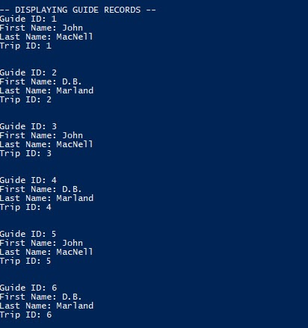

Customer table output:

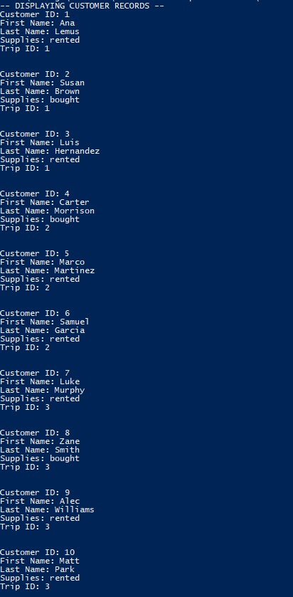

Supply Table output:

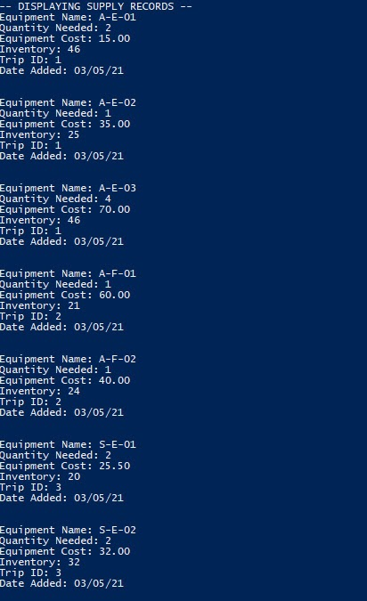

Trip Table Output:

